
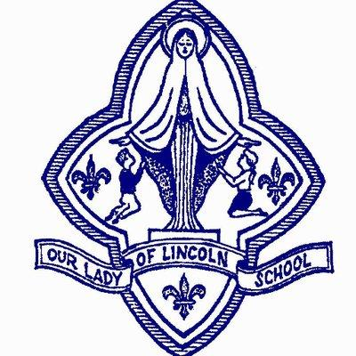
Admissions Privacy Notice
This notice explains what personal data (information) we hold and process relating to our admission procedures including how we collect and how we use and may share information about you. We are required to give you this information under data protection law.
Who we are
Our Lady of Lourdes Catholic Multi-Academy Trust (CMAT) collects, uses and is responsible for certain personal information about you. When we do so we are regulated under the General Data Protection Regulation which applies across the European Union (including in the United Kingdom) and we are responsible as ‘controller’ of that personal information for the purposes of those laws. Our Data Protection Officers (DPO) are Tamer Robson and Teresa Bettelley who can both be contacted using the following email address: dpo@ololcatholicmat.co.uk.
Our Lady of Lourdes CMAT is the admissions authority for all admissions to the academies within the CMAT. The CMAT and each academy works with the relevant Local Authorities to administer the school admissions process. The Primary Admissions process for entrance to reception (Year R) begins in November when applications are submitted, through to National Offer Day on 16th April. The Secondary school admissions process for entrance to Year 7 starts in October when applications are submitted, through to National Offer Day on 1st March each year.
The In-Year Admissions process includes all children who move schools through the school year, across all year groups.
Personal information we collect and use
Information received by us
In the course of admitting children to one of our academies we may receive some or all of the following personal data from the relevant Local Authority:
•your personal information (such as name, address, contact details)
•your child’s personal information (such as name, address, date of birth)
•current school (if applicable)
•school preference information and parent’s reasons for selection
•name and date of birth of any sibling already attending one of our academies
•looked after children, adoption, special guardianship order or child arrangement history
•special category information including details of your child’s Education Health and Care Plan status
We also collect directly the following personal information:
•additional admissions information relating to your faith if you are applying on faith grounds (such as religious beliefs, evidence of baptism, church attended)
•additional details relating to your child’s Special Educational Needs and Disabilities requirements
How we use your personal information
We use your personal information to:
- In the normal admissions round - rank your application according to our published oversubscription criteria and forward the ranked list to the Local Authority in line with their timescales in order that they can then issue offer letters
- For in year admissions – determine where on the waiting list your application will be ranked and inform the Local Authority
- we may use your personal details to contact you to seek clarification about your application
How long your personal data will be kept
We will hold your personal information securely and retain it only as long as is necessary to administer the normal admissions round, in year admissions and any appeals.
Children admitted to one of our academies: personal data will be transferred to the academy MIS and retained in line with our Retention & Destruction Schedule and Pupil Privacy Notice.
Children not admitted during the normal round, during in year admission or through appeal: personal data will be retained for one year following the resolution of the case and then securely destroyed.
Keeping this information safe
It is very important that only people who need to use your information can see it. The school keeps your information safe by:
- Ensuring that only authorised people have access to it
- It is transmitted in a safe and secure manner
- Ensuring we have internal policies and controls in place to ensure that personal data is not lost, accidentally destroyed, misused or disclosed, and is not accessed by anybody without the required permissions
Why do we use special category personal data?
- We may need to use special category information about you where there is a specific interest to do so for example health and social care purposes or to provide you with equal opportunities and treatment. We will also use this information where you have given us permission to do so.
- There may also be circumstances where we need to use your information in relation to legal claims, or to protect your vital interests and where you are unable to provide your consent.
Our legal basis for using this data
- Most commonly, we process it where:
  - We need to comply with a legal obligation
  - We need it to perform an official task in the public interest
- Less commonly, we may also process your personal data in situations where:
  - We have obtained consent to use it in a certain way
  - We have a contractual obligation to process this information
  - We need to protect the individual’s vital interests (or someone else’s interests)

Your rights in relation to your information
You can ask to see the information we hold about you. If you wish to do this, you should contact:
DPOs Tamer Robson and Teresa Bettelley: dpo@ololcatholicmat.co.uk
You also have the right to:
- Object to what we are doing with your information
- Have inaccurate or incomplete information about you amended
- Ask us to stop doing certain things with your information in some cases
- Ask that decisions about you are not made using automatic systems
- Claim against the School/Trust in certain circumstances where you have suffered as a result of the School/Trust breaching your data protection rights
If you feel it necessary to do any of the above, you can contact:

DPOs Tamer Robson & Teresa Bettelley: dpo@ololcatholicmat.co.uk

Last Updated
We may need to update this privacy notice periodically, so we recommend that you revisit this
information from time to time. This version was last updated February 2025.

