Our Lady of Lincoln Catholic Primary School

Art Curriculum

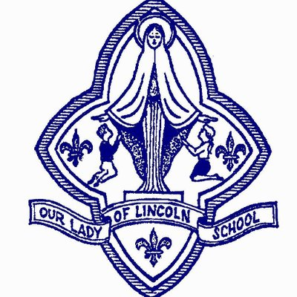

Art Whole School Long Term Overview
 | Content 1 | Content 2 | Art Day
YEAR 1 | Sculpture  Natural Resources  Artist Focus: Goldsworthy  Is Rock Balancing a good idea? | Drawing and Painting  Colour and Printmaking  Artist focus: Kandinsky  Can Maths be Art? | Chauvet Cave Art
YEAR 2 | Drawing and Painting  Art from Other Cultures  Aborigional  Tinga Tinga  Egyptian Art  Should artists use realistic colours for Art to be effective? | Sculpture  Community Sculpture  Can Art change the community? | Picasso  ‘The Weeping Woman’
YEAR 3 | Drawing and Paintin  PopArt Movement (1950s)  Artist Focus: Andy Warhol, Rosalyn Drexler, Roy Lichtenstein  Can ordinary things become Art? | Drawing and Painting  Landscapes – watercolours  Artist Focus: Turner, Constable, Monet  Are all landscapes the same? | Colin Carr  Life in Lincolnshire
YEAR 4 | Drawing and Painting  Post-Impressionism (1880 – 1905)  Artist Focus: Van Gogh, Henri Rousseau, Gauguin  Do you like Van Gogh’s Sunflowers? | Sculpture  Artist Focus: Giacometti, Augusta Savage  Is an artists’ work ever finished? | Recycled Art Sculptures
YEAR 5 | Drawing and Painting  Street Art (1990 -)  Artist Focus: Banksy  Is Banksy a vandal? | Drawing and Painting  Abstract Expressionism (1940-  Artist Focus: Jackson Pollock, Helen Frankenthaler, Arshile Gorky, Janet Sobe  Should Art have meaning? | Edvard Munch  ‘Scream’
YEAR 6 | Sculpture and Digital Art  Artist Focus: Goldsworthy  Can nature become Art? | Drawing and Painting  Surrealism (1920-50)  Artist Focus: Salvador Dali, Frida Kahlo, Andre Breton  Should Art be shocking? | Leonardo Da Vinci  ‘The Mona Lisa’  Kehinde Wiley  ‘Barack Obama’
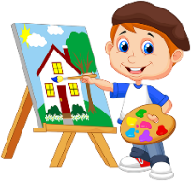
Year 1 Art Programme of Study
Project: Colour and Printmaking: Kandinsky
Question: Can Maths be Art?
NB: This project should be taught after Shapes have been taught in Maths.
Curriculum aims: Be positive, Be respectful, Be resilient, Be independent, Be knowledgeable, Be ambitious, Be confident.
Curriculum drivers: Communication, Health, World Citizen, Beliefs, Aspiration
Key Knowledge (the non-negotiable facts)  Ask the project question at the start of the unit:  To know how I feel about artwork. (Communication Beliefs)  - Talk about artwork (by Kandinsky), sharing likes and dislikes  - Make links between pieces of artwork by the same artist.  - Make links between my own work and the work of Kandinsky  To know some key facts about Kandinsky and his work. (Aspiration)  - He was a Russian painter and printmaker  - He was an important figure in modern art.  - He was fascinated by colour as a child.  - He was interested in how shapes are used in Art.  To know how to mix secondary colours and begin exploring tone and shade  - Make a colour wheel and use this for reference in future work  - Add white and black to colours to change the tone  To know how to use printing techniques to produce a clean printed image  - Use mono-printing and overprinting techniques correctly  - Use rollers or print palettes  To know how to use computing to create a picture (Communication)  - Microsoft paint- draw shapes, lines and change colours NB “Swinging” by Kandinsky  - Save and retrieve work.  To know a range of printing and painting techniques from this unit:  - End product will be a printed piece of artwork on the style of Kandinsky, using colours mixed from primary colours, black and white  Refer back to the project question at the end of the unit: | Key concepts (artistic skills) from progression document  Developing ideas  *Build information on colour mixing, the colour wheel and colour spectrums  *Use a sketchbook to plan and develop simple ideas  Painting  *Begin to control the types of marks made in a range of painting techniques e.g. layering, mixing media and adding texture  *Understand how to make tints using white and tones by adding black to make darker and lighter shades  *understand the colour wheel and colour spectrums  *Be able to mix all the secondary colours confidently  Printmaking  *Continue to explore printing simple pictures with a range of hard and soft materials  *Demonstrate experience at impressed printing: drawing into ink, printing from objects  *Use equipment and media correctly and be able to produce a clean printed image.  *Take simple prints- mono-printing  *Make simple marks on rollers and printing palettes  *Experiment with over-printing motifs and colour  Texture, pattern, colour, line and tone  *Use line and tone in different media to consider shape, shade, pattern and texture.  Art through technology  *Use a simple computer paint program to create a picture  Responding to art  • Look at and talk about own work and that of other artists and the techniques they had used, expressing their likes and dislikes.  *Explore the work of a range of artists, craftmakers and designers, describing the differences and similarities and making links to their own work.  *Express thoughts and feelings about a piece of art. | Core vocabulary:  Tier 3  Mono-print  Over printing  Tints  Tones  Primary colours  Secondary colours  Tier 2  Darker  Lighter  Tone  Shade  Mix
Curriculum threads to be covered:-
Reading –
- Listen to and discuss a wide range of poems, stories and non-fiction at a level beyond that at which they can read independently,
- Be encouraged to link what they read or hear read to their own experiences,
- Participate in discussion about what is read to them, taking turns and listening to what others say.
- Explain clearly their understanding of what is read to them.
Computing –

British Values :
- To enable students to develop their self-knowledge, self-esteem and self-confidence (to grow in self-esteem and self-confidence when talking about their own work: techniques used, likes and dislikes)
- To encourage respect for other people (to grow in respect when expressing thoughts and feelings about their own work and work of a range of artists).
PSHE – Health and Wellbeing˃ Healthy Lifestyles - CORAM Life Education- Our Feelings (Year 1)

Previous learning which will support the learning and skill development in this topic:
EYFS-ELG 12 Shape, space and measures
ELG 16 Exploring and using media and materials
ELG 17 Being imaginative
Year 1 unit 1: Printing techniques introduced- mono-printing; line and pattern explored; responding to art

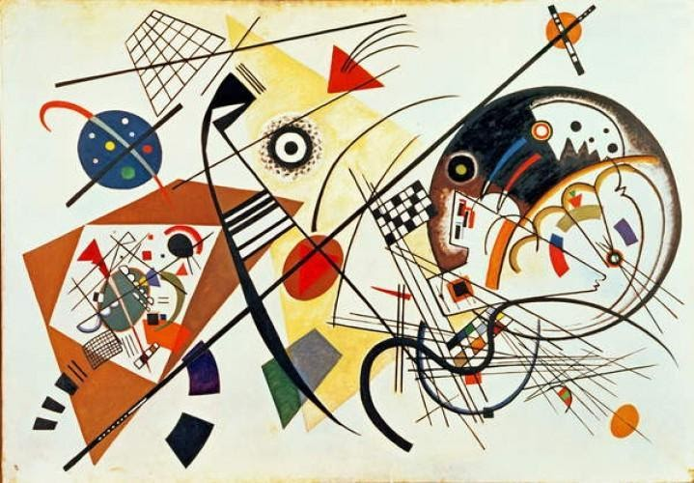
Year 1 Art Programme of Study
Project: Contemporary Environmental Sculpture: Andy Goldsworthy
Question: Is rock balancing a good idea?
Curriculum aims: Be positive, Be respectful, Be resilient, Be independent, Be knowledgeable, Be ambitious, Be confident.
Curriculum drivers: Communication, Health, World Citizen, Beliefs, Aspiration
Key Knowledge (the non-negotiable facts)  Ask the project question at the start of the unit:  To know appropriate vocabulary to talk about how art affects us:  (Communication)  - Talk about the work of Andy Goldsworthy and what they like/dislike  - Make links between pieces of artwork by the same artist  - Make links between our own work and the work of Andy Goldsworthy (at the end of the unit)  To know how natural materials can be used to create artwork:  (World Citizen Communication)  - Describing materials, including texture  - Combine materials together and photograph these  - Use natural materials to make impressions in clay  - Use natural materials to make prints  To know how to use different media to draw from observation:  - Explore ways to use a range of media in different ways, including work on different surfaces.  - Develop control over types of marks made.  - Focus on showing textures  To know how texture can be used to improve artwork:  - Explore and describe textures and patterns they encounter.  - Use printing, impression and drawing techniques to show texture  To know a range of drawing and sculpting techniques from this unit:  (World Citizen, Beliefs, Aspiration)  - End product will be a sculpture using natural materials and clay  - End product will show a range of textures  Refer back to the project question at the end of the unit: | Key concepts (artistic skills) from progression document  Developing ideas  *Collect textures and patterns to inform other work.  *Use a sketchbook to plan and develop simple ideas  Drawing:  ∙ Experiment with a variety of media: pencils, rubbers, crayons, pastels, felt tips, charcoal, pen, chalk.  *Begin to control the types of marks made with the range of media.  *Draw on different surfaces with a range of media.  *Draw lines/marks from observation.  Sculpture  ∙ Experiment in a variety of malleable media such as clay, papier mache, salt dough, modroc  *Use tools and equipment safely in the correct way.  *Impress and apply simple decoration techniques, including painting.  Printmaking  *Continue to explore printing simple pictures with a range of hard and soft materials  *Demonstrate experience at impressed printing: printing from objects  *Take simple prints- mono-printing  Texture, pattern, colour, line and tone  • Demonstrate experience in surface patterns/textures and use them when appropriate  *Use natural materials to consider pattern and texture.  *Use line and tone in different media to consider shape, shade, pattern and texture.  Art through technology  *Take a photograph or self portrait  *understand how to use ‘zoom’ to show an object in detail- e.g. using a viewfinder to focus on a specific part of an artefact before drawing it  Responding to art  • Look at and talk about own work and that of other artists and the techniques they had used, expressing their likes and dislikes.  *Explore the work of a range of artists, craftmakers and designers, describing the differences and similarities and making links to their own work.  *Express thoughts and feelings about a piece of art. | Core vocabulary:  Tier 3  Malleable  Environment  Mono-print  Tier 2  Pattern  Texture  Rough  Smooth  Lumpy  Lined  spotted  Delicate  Firm  Construct  combine  natural  uniform  irregular
Curriculum threads to be covered:-
Reading –
- Listen to and discuss a wide range of poems, stories and non-fiction at a level beyond that at which they can read independently.
- Participate in discussion about what is read to them, taking turns and listening to what others say.
- Discuss word meanings, linking new meanings to those already known.
- Drawing on what they already know or on background information and vocabulary provided by the teacher.
Computing –

British Values:
- To enable students to develop their self-knowledge, self-esteem and self-confidence (to grow in confidence when exploring techniques independently; to grow in self-esteem and self-confidence when talking about their own work: techniques used, likes and dislikes).
- To encourage respect for other people (to grow in respect and values of positive feedback when expressing thoughts and feelings about a piece of art done by others and other artists).

PSHE – Living in the Wider World ˃Caring for the Environment- CORAM Life Education- Around and about the school (Year 1)
Relationships ˃Healthy Relationships- CORAM Life Education- Pass on the Praise! (Year 1)
Relationships ˃Healthy Relationships- CORAM Life Education- Sharing opinions:cross-curricular skills (Year 1)
Previous learning which will support the learning and skill development in this topic:
EYFS-ELG 16 Exploring and using media and materials
ELG 17 Being imaginative
thickness and tone using a pencil, producing patterns and textures from observation, building constructions, using malleable materials, taking rubbings
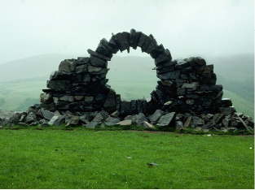
Year 2 Art Programme of Study
Project: Community Art Project
Question: Can art change the community?
Curriculum aims: Be positive, Be respectful, Be resilient, Be independent, Be knowledgeable, Be ambitious, Be confident.
Curriculum drivers: Communication, Health, World Citizen, Beliefs, Aspiration
Key Knowledge (the non-negotiable facts)  Ask the project question at the start of the unit:  To know ways to manipulate malleable materials to create different shapes, effects, patterns and textures  - Use tools and freehand work to shape malleable materials safely  - Use rolling, pinching, kneading and impressing techniques  To know how to gather information and plan a project.  - Use ideas listed below to begin planning a community project or an idea that the children think of that reflects the brief and skills.  - Research potential ideas and use the sketchbook to record ideas.  - Understand the various stages of the project and what will need to be completed first, next etc.  To know how to apply pencil techniques to plan and develop ideas (Communication)  - Plan and develop ideas effectively using drawing techniques developed in the previous unit.  - Use hatching, stippling etc to add tone and texture to drawings.  To know about carving as a form of 3D art (Aspiration Communication)  - Compare sculptures that have been cast, moulded and carved looking at some well known examples..  - Explore carving techniques to remove material to create shape and texture e.g. clay tile, oasis, polystyrene  To know a range of sculpture techniques from this unit:  (World Citizen, Aspiration, Health)  - End product will be varied from year to year so that cohorts make unique community art projects to display in the school grounds. For example:  - a series of decorated planters/pots  - OR a mural of tiles decorated by the pupils and collated into one piece of community art  - OR a series of figure sculptures e.g. gnomes, fairies, pixies for the nature garden  - OR a similar community project to enrich the school environment which uses malleable materials.  NB Artwork should be coated in a weatherproof varnish to extend its lifespan for outdoor display. This can be done by staff for safety.  Refer back to the project question at the end of the unit: | Key concepts (artistic skills) from progression document  Developing ideas  *Collect textures and patterns to inform other work.  *Use a sketchbook to plan and develop simple ideas  Drawing:  *Develop a range of tone using a pencil and use a variety of drawing techniques such as: hatching, scribbling, stippling and blending to create light/dark lines  *Continue to investigate tone by drawing light/dark lines, light/dark patterns, light/dark shapes using a pencil  Sculpture  *Shape and model materials for a purpose (e.g. a pot, tile) from observation and imagination.  *Continue to manipulate malleable materials in a variety of ways including rolling, pinching and kneading.  *Use tools and equipment safely and in the correct way  *Use equipment and media with increasing confidence.  *Use clay, modroc or other malleable materials to create an imaginary or realistic form.e.g. clay pot, figure, structure  *Explore carving as a form of 3D art  Texture, pattern, colour, line and tone  *Demonstrate experience in surface patterns/textures and use them when appropriate  *Investigate textures and produce an expanding range of patterns.  Responding to art  *Reflect and explain the successes and challenges in a piece of art created.  *Explain how a piece of art makes them feel- link to emotions. Identify changes they might make or how their work could be developed further. | Core vocabulary:  Tier 3  Hatching, stippling,  impress  Tier 2  success  challenge  roll  pinch  knead  malleable  tone  texture  pattern  carve  community  weatherproof
Curriculum threads to be covered:-
Reading –
- Listen to, discuss and express views about a wide range of contemporary and classic poetry, stories and non-fiction at a level beyond that at which they can read independently,
- Be introduced to non-fiction books that are structured in different ways,
- Participate in discussion about books, poems and other works that are read to them and those that they can read for themselves, taking turns and listening to what others say.
Computing –

British Values
- To enable students to develop their self-knowledge, self-esteem and self-confidence (to develop these skills when reflecting and explaining the successes and challenges of a piece of art work).
- To encourage students to accept responsibility for their behaviour, show initiative, and to understand how they can contribute positively to the lives of those living and working in the locality of the school and to society more widely (to develop greater social awareness of the school and locality and to apply this knowledge when planning and creating their art work- explore how their community sculpture will have a positive impact on the school/locality).
PSHE – Living in the Wider World ˃Caring for the Environment- CORAM Life Education- How can we look after our environment? (Year 2)
Relationships˃Valuing Difference- CORAM Life Education- An Act of Kindness (Year 2)

Previous learning which will support the learning and skill development in this topic:
EYFS-ELG 13 People and Communities
ELG 16 Exploring and using media and materials
ELG 17 Being imaginative
Y1- Goldsworthy sculpture with exploration of malleable materials.
Y1- Developing understanding of, and vocabulary associated with, texture
Y2- Drawing techniques to show pattern/texture/tone developed

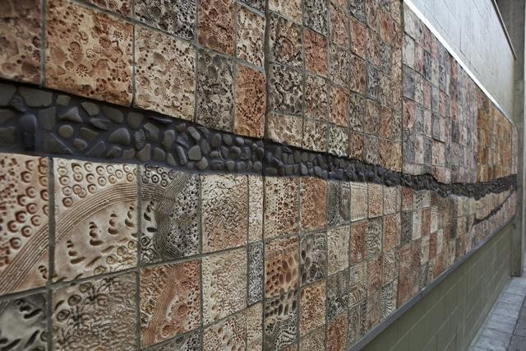

Year 2 Art Programme of Study
Project: Drawing and painting- art from other cultures
Question: Should artists use realistic colours for art to be effective?
Curriculum aims: Be positive, Be respectful, Be resilient, Be independent, Be knowledgeable, Be ambitious, Be confident.
Curriculum drivers: Communication, Health, World Citizen, Beliefs, Aspiration
Key Knowledge (the non-negotiable facts)  Ask the project question at the start of the unit:  To know key features of artwork from other cultures, including TingaTinga and aboriginal art (World Citizen Communication Beliefs)  - Explore how colour and line is used and how it affects our emotions  - Compare the work of different cultures, including similarities and differences  - Talk about subject matter and style  - Reflect this within own work  To know how to use pencil techniques to show tone and texture  - Use different grades of pencil and drawing techniques to make dark and light  - Use hatching, stippling etc to add tome and texture to drawings.  - Show control over marks  - Link to aboriginal art  To know how to mix a range of colours, shades, tints and tones: (Communication)  - Use the colour wheel when mixing colours.  - Add black and white to colours to makes tints and shades  - Mix own colours for use in artwork.  - Link to Tinga Tinga  To know a range of drawing and painting techniques from this unit:  (World Citizen, Beliefs, Aspiration)  - End product will be a Tinga Tinga style painting using bold colour and line  - End product will be a textured drawing inspired by aboriginal art  Refer back to the project question at the end of the unit | Key concepts (artistic skills) from progression document  Developing ideas  *Build information on colour mixing, the colour wheel and colour spectrums  *Use a sketchbook to plan and develop simple ideas  Drawing:  *Develop a range of tone using a pencil and use a variety of drawing techniques such as: hatching, scribbling, stippling and blending to create light/dark lines  *Continue to investigate tone by drawing light/dark lines, light/dark patterns, light/dark shapes using a pencil  *Demonstrate control over the types of marks made with a range of media such as crayons, pastels, felt tips, charcoal, pen, chalk  *understand tone through the use of different grades of pencils (HB, 2B, 4B)  Painting  *Begin to control the types of marks made in a range of painting techniques e.g. layering, mixing media and adding texture  *Understand how to make tints using white and tones by adding black to make darker and lighter shades.  *Build confidence in mixing colour shades and tones  *Continue to control the types of marks made with the range of media.  *Use a suitable brush to produce marks appropriate to work E.G. small brush for small marks.  Texture, pattern, colour, line and tone  *Express links between colour and emotion  *Use line and tone in different media to consider shape, shade, pattern and texture.  Responding to art  *Explore the work of a range of artists, craftmakers and designers, describing the differences and similarities and making links to their own work.  *Reflect and explain the successes and challenges in a piece of art created.  *Explain how a piece of art makes them feel- link to emotions. Identify changes they might make or how their work could be developed further. | Core vocabulary:  Tier 3  Hatching, stippling,  TingaTinga  Aboriginal  stylised  Tier 2  blending  tone  shade  success  challenge  Primary colours  Secondary colours  Bold
Curriculum threads to be covered:-
Reading –
- Listen to, discuss and express views about a wide range of contemporary and classic poetry, stories and non-fiction at a level beyond that at which they can read independently,
- Discuss the sequence of events in books and how items of information are related,
- Discuss and clarify the meanings of words, linking new meanings to known vocabulary,
- Draw on what they already know or on background information and vocabulary provided by the teacher.
Computing –

British Values:
- To enable students to develop their self-knowledge, self-esteem and self-confidence (to develop these skills when reflecting and explaining the successes and challenges of a piece of art created and when looking at how their work can be developed further).
- To further tolerance and harmony between different cultural traditions by enabling students to acquire an appreciation of and respect for their own and other cultures (to develop respect for other cultural traditions when exploring artists, craftmakers and designers from other cultures).
- To encourage respect for other people (to develop respect for themselves and others when sharing a piece of art and giving positive feedback).
PSHE – Relationships ˃ Feelings and emotions- CORAM Life Education- How are you feeling today? (Year 2)
Living in the Wider World ˃ Rules,Rights and Responsibilities- CORAM Life Education- When I feel like erupting (Year 2)
Previous learning which will support the learning and skill development in this topic:
EYFS-ELG 14 The World
ELG 16 Exploring and using media and materials
ELG 17 Being imaginative
Y1- colour wheel and mixing secondary colours, tints and shades.
Y1- Experimenting with a range of drawing media and mark-making
Y1- Developing understanding of, and vocabulary associated with, texture
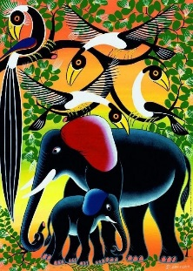
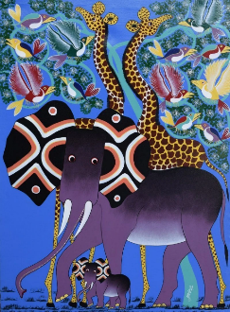
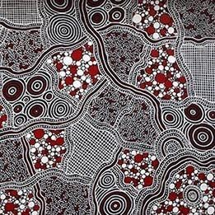
`

Year 3 Art Programme of Study
Project: Pop Art- Andy Warhol, Rosalyn Drexler, Roy Lichtenstein
Question: Can ordinary things become art?
Curriculum aims: Be positive, Be respectful, Be resilient, Be independent, Be knowledgeable, Be ambitious, Be confident.
Curriculum drivers: Communication, Health, World Citizen, Beliefs, Aspiration
Key Knowledge (the non-negotiable facts)  Ask the project question at the start of the unit:  To know about the pop-art movement and key artists, responding to their work. (Aspiration)  - Pop art is an art movement that emerged in the United Kingdom and the United States during the mid- to late-1950s. The movement presented a challenge to traditions of fine art by including imagery from popular and mass culture, such as advertising, comic books and mundane mass-produced cultural objects.  - It began as a revolt against the dominant approaches to art and culture and traditional views on what art should be. Young artists felt that what they were taught at art school and what they saw in museums did not have anything to do with their lives or the things they saw around them every day. Instead they turned to sources such as Hollywood movies, advertising, product packaging, pop music and comic books for their imagery.  - Key knowledge about Andy Warhol and Roy Lichtenstein and Rosalyn Drexler  To know how to show simple perspective and the third dimension  - Stimulus- Roy Lichtenstein “house” sculptures, Andy Warhol Campbell’s soup  - Show perspective to a point for simple, straight shapes such as buildings  - Develop showing the third dimension for common 3D shapes  To know how to use a range of printing techniques:  ( Communication)  - Create repeating patterns using mono-printing e.g. Marilyn Monroe by Warhol, developing clean printing technique  - Print on different media, including fabric  - Develop relief printing by building a design onto a board to stamp  - Plan multiple relief boards to be used together with different colours to build up a 3 colour design.  - Explore the effect of complimentary and contrasting colours  - Describe similarities and differences between printing techniques and media.  To know how art can combine digital images with other media:  - Discuss the work of Rosalyn with the juxtaposition of figures on bright, block colour backgrounds  - Take photographs of figures to use within a mixed-media piece  - Explain choice of complimentary or contrasting colours after trying out ideas.  To know how to use a range of printing techniques to create effective pop-art inspired artwork:  - End product will be a piece of printed artwork which uses 3 colours, based upon popular culture.  - Discuss own and others work using knowledge and understanding of printing techniques and Pop Artists.  Refer back to the project question at the end of the unit: | Key concepts (artistic skills) from progression document  Developing ideas  *Use a sketchbook to record media explorations and experimentations as well as try out ideas, plan colours and collect sources material for future works  Drawing:  *Have opportunities to develop further drawings featuring the third dimension and perspective  Painting:  *Mix Colours, shades and tones with increasing confidence  Printmaking  *Print simple pictures using different printing techniques.  *Increase awareness of relief and mono-printing  *Continue to explore both mono-printing and relief printing  *Demonstrate experience in 3 colour printing  *Demonstrate experience in combining prints taken from different objects  *Demonstrate experience in fabric printing  *Create repeating patterns  Texture, pattern, colour, line and tone  *Use complimentary and contrasting colours for effect.  Art through technology  *Use printed images taken with a digital camera and combine them with other media to produce artwork.  *Create a piece of art which includes integrating a digital image they have taken  Responding to art  *Continue to explore the work of a range of artists, craftmakers and designers, describing the differences and similarities between different practices and disciplines, and making links to their own work.  *Discuss own and others work, expressing thoughts and feelings, and using knowledge and understanding of artists and techniques  *Respond to art from other cultures and other periods of time. | Core vocabulary:  Tier 3  Mono-printing  Relief printing  Tier 2  Contrasting  Complimentary  Perspective  3-dimensional  Designers  Popular culture  Digital images  Mixed-media
Curriculum threads to be covered:-
Reading –
- Listen to and discuss a wide range of fiction, poetry, plays, non-fiction and reference books or textbooks,
- Check that the text makes sense to them, discussing their understanding and explaining the meaning of words in context,
- Ask questions to improve their understanding of a text,
- identify main ideas drawn from more than one paragraph and summarising these,
- Retrieve and record information from non-fiction,
- Participate in discussion about both books that are read to them and those they can read for themselves, taking turns and listening to what others say.
Computing –

British Values :
- To enable students to develop their self-knowledge, self-esteem and self-confidence (to develop these skills when discussing their own and others work and expressing thoughts and feelings using knowledge and techniques from other artists).
- To encourage students to accept responsibility for their behaviour, show initiative, and to understand how they can contribute positively to the lives of those living and working in the locality of the school and to society more widely (to develop awareness of the pop-art movement and key artists who contributed towards it; to link this to their own potential to show initiative and therefore make a difference and contribute positively to the school/locality).
- To encourage respect for other people (to develop respect for artists and their views which challenged traditions of fine art; to develop respect when discussing the work of others).
PSHE – Relationships ˃Feelings and Emotions - CORAM Life Education- Respect and Challenge (Year 3)
Relationships ˃Feelings and Emotions - CORAM Life Education- Let’s celebrate our differences (Year 3)
Previous learning which will support the learning and skill development in this topic:
EYFS-ELG 16 Exploring and using media and materials
ELG 17 Being imaginative
Y1- Kandinsky- Impressed printing, mono-printing, over-printing, producing a clean printed image
Y1- Goldsworthy- Taking a digital photograph using ‘zoom’
Y2- Art from other cultures- use of complimentary and contrasting colours, how colours make us feel.
Y2- Community art project- carving/cutting away

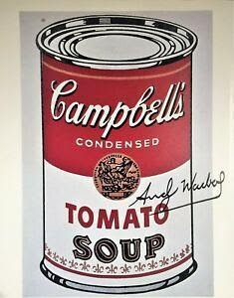

Year 3 Art Programme of Study
Project: Watercolour Landscapes- Turner, Constable, Monet
Question: Are all landscapes the same?
Curriculum aims: Be positive, Be respectful, Be resilient, Be independent, Be knowledgeable, Be ambitious, Be confident.
Curriculum drivers: Communication, Health, World Citizen, Beliefs, Aspiration
Key Knowledge (the non-negotiable facts)  Ask the project question at the start of the unit:  To know and respond to key pieces of art from well-known landscape painters. (Aspiration)  - Key artists of focus - Turner, Constable, Monet  - Children to critique well known paintings of these artists looking at the artistic elements.  To know ways to utilise a sketchbook to develop ideas and improve work  (Communication)  - Develop the sketchbook as a working document to develop ideas through annotation and note-making  - Develop use of the sketchbook to collect ideas and inspiration for work  To know how to show textures and tones when drawing from observation  - Explore observational drawing of natural objects relevant to landscapes, such as foliage, wood, grass, water. Some drawings should be made outdoors.  - Develop stamina for drawing for extended periods with appropriate detail  - Develop further ways to show texture through line and tone.  To know how to show reflections in a drawing:  - Explore how key artists show reflection in water.  - Experiment with showing similar, simple reflections in own work.  To know how to use colour and tone in the style of Monet:  (Aspiration Communication)  - Use observational drawing work as a starting point for the painting  - Experiment with blocking in colour washes as a base, adding complementary colours layered over the top of the dried base to add the detail and texture.  - Experiment with techniques to show varied and textured foliage in the style of Monet.  - Thoroughly discuss and evaluate, making annotations in sketchbooks with links to the work of Monet  To know how to use a range of painting techniques to create a landscape:  - End product will be a watercolour landscape painting. Pupils should colourwash blocks as a base in complementary colours to the detail and texture layered over the top.  Refer back to the project question at the end of the unit: | Key concepts (artistic skills) from progression document  Developing ideas  *Use a sketchbook to record media explorations and experimentations as well as try out ideas, plan colours and collect sources material for future works  *Make notes in a sketchbook about techniques used by artists.  *Annotate ideas for improving their work through keeping notes in a sketchbook.  Drawing:  *Develop intricate patterns using different grades of pencil and other implements to create lines and marks  *Further develop drawing a range of tones, lines using a pencil  *Draw for a sustained period of time at an appropriate level  *Begin to show awareness of representing texture through the choice of lines and marks made.  *Attempt to show reflections in a drawing.  Painting:  *Confidently control the types of marks made and experiment with different effects and textures including blocking in colour, washes, thickened paint creating textural effects  *Start to develop a painting from a drawing  *Work in the style of a selected artist (not copying)  *Mix Colours, shades and tones with increasing confidence  Texture, pattern, colour, line and tone  *Use complimentary and contrasting colours for effect.  Responding to art  *Continue to explore the work of a range of artists, craftmakers and designers, describing the differences and similarities between different practices and disciplines, and making links to their own work.  *Discuss own and others work, expressing thoughts and feelings, and using knowledge and understanding of artists and techniques  *Begin to explore a range of great artists, architects and designers in history.  *Respond to art from other cultures and other periods of time. | Core vocabulary:  Tier 3  Water-colour  Wash  Colour-blocking  Tier 2  Layering  Complimentary  Contrasting  Foliage  reflection  Texture  Line  Colour  Annotate  Evaluate  observational
Curriculum threads to be covered:-
Reading –
- Listen to and discuss a wide range of fiction, poetry, plays, non-fiction and reference books or textbooks,
- Retrieve and record information from non-fiction.
- Use dictionaries to check the meaning of words that they have read,
- Check that the text makes sense to them, discussing their understanding and explaining the meaning of words in context,
- Ask questions to improve their understanding of a text,
- Retrieve and record information from non-fiction,
- Participate in discussion about both books that are read to them and those they can read for themselves, taking turns and listening to what others say.
Computing –

British Values:
- To enable students to develop their self-knowledge, self-esteem and self-confidence (to develop these skills when discussing their own and others work and expressing their thoughts and feelings using knowledge and techniques from other artists).
- To encourage respect for other people (to develop respect for others when exploring a range of artists and looking at their practices and disciplines; to develop respect for others when discussing the work of others).
PSHE - N/A
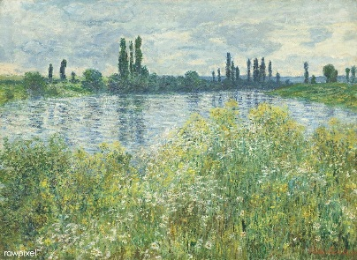
Previous learning which will support the learning and skill development in this topic:
EYFS-ELG 16 Exploring and using media and materials
ELG 17 Being imaginative
Y1- Goldsworthy- revisit art inspired by nature.
Y2- Drawing and Painting from other cultures- confidence with colour mixing and controlled mark making with paint, drawing techniques explored, showing tone with a pencil and using different pencil grades.
Y2- Community art project- developing ideas using a sketchbook and evaluating success.
Y3- Pop art- complimentary and contrasting colours, beginning to use sketchbooks to gather source material

Year 4 Art Programme of Study
Project: Post-Impressionism (Van Gogh, Henri Rousseau, Gauguin)
Question: Do you like Van Gogh’s ‘Sunflowers’?
Curriculum aims: Be positive, Be respectful, Be resilient, Be independent, Be knowledgeable, Be ambitious, Be confident.
Curriculum drivers: Communication, Health, World Citizen, Beliefs, Aspiration
Key Knowledge (the non-negotiable facts)  Ask the project question at the start of the unit:  To know what is meant by the post-impressionism movement and some of the key artists and works from this time. (Aspiration)  - Post means after so this means after impressionism.  - These artists developed impressionism but rejected its limitations. They continued using the real-life subject matter, with vivid colours, often with thick paint. However, they added other ideas. Using geometric forms, to distorting form for effect, and using unnatural colours are some of their ways.  - Share knowledge about key artists Van Gogh, Henri Rousseau and Gauguin and some of their most famous works.  To know how to utilise a sketchbook to develop, improve and express feelings (Communication)  - Further develop the sketchbook as a working document to develop ideas through annotation and note-making  - Further develop use of the sketchbook to collect ideas and inspiration for work  - Begin to use a sketchbook to express feelings about starting points, artists’ work and their own ideas.  To know how to use different types of paint and choose appropriate media for a project (Communication, Beliefs)  - Using previous work using watercolour in year three as a starting point, explore different types of paint.  - Develop techniques to use acrylic, oil, thickened paint, watercolours  - Using work of key artists, including The Yellow Christ by Gauguin, make links between the type of media and suitability for different styles of painting.  To know how to make 3 colour prints using different objects (Aspiration Communication)  - Using Van Gogh’s sunflower paintings as a starting point, further develop experience of printmaking using 3 colours.  - Discuss how the original series of paintings makes you feel and why they became so popular.  - Develop a repeating print of 3 colours and link to the artist’s work  To know how to use a range of painting techniques to create a landscape:  (World Citizen Aspiration Communication)  - End product will be a jungle painting inspired by the work of Henri Rousseau, in the post-impressionist style.  - End product will be painted using media chosen by pupils, explaining choices based on experience of media and knowledge of the post-impressionism movement.  Refer back to the project question at the end of the unit: | Key concepts (artistic skills) from progression document  Developing ideas  *Use a sketchbook to record media explorations and experimentations as well as try out ideas, plan colours and collect sources material for future works  *Make notes in a sketchbook about techniques used by artists.  *Annotate ideas for improving their work through keeping notes in a sketchbook.  *Use a sketchbook to express feelings about a subject  *Identify interesting aspects of objects as a starting point for work.  Painting:  *Confidently control the types of marks made and experiment with different effects and textures including blocking in colour, washes, thickened paint creating textural effects  *Start to develop a painting from a drawing  *Work in the style of a selected artist (not copying)  *Mix Colours, shades and tones with increasing confidence  *Begin to choose appropriate media to work with.  *Use light and dark within painting and show understanding of complementary colours.  Printmaking:  *Expand experience in 3 colour printing  *Continue to experience in combining prints taken from different objects to produce an end piece  *Create repeating patterns.  Responding to art  *Continue to explore the work of a range of artists, craftmakers and designers, describing the differences and similarities between different practices and disciplines, and making links to their own work.  *Discuss own and others work, expressing thoughts and feelings, and using knowledge and understanding of artists and techniques  *Begin to explore a range of great artists, architects and designers in history.  *Discuss and review own and others’ work, expressing thoughts and feelings, and identify modifications/changes and see how they can be developed further. | Core vocabulary:  Tier 3  Post-impressionism  Tier 2  Media  Acrylic  Oil paint  Thickened paint  Texture  Watercolour  Annotation  Complimentary  contrasting
Curriculum threads to be covered:-
Reading –
- Listening to and discussing a wide range of non-fiction and reference books or textbooks
- Draw inferences from paintings, justifying reasons with artistic evidence.
- Retrieve and record information from non-fiction.

Computing –

British Values :
- To enable students to develop their self-knowledge, self-esteem and self-confidence (to develop these skills when discussing own and others work and expressing thoughts and feelings using knowledge and understanding of artists and their techniques).
- To encourage students to accept responsibility for their behaviour, show initiative, and to understand how they can contribute positively to the lives of those living and working in the locality of the school and to society more widely (to explore the work and its impact from key artists in the post-impressionism movement; to explore how their initiative contributed positively to society more widely; to link this with pupils’ own potential to use initiative to make a positive contribution to the school/locality).
- To encourage respect for other people (to develop respect for others when discussing and reviewing own and others work and identifying modifications: seeing how these can be developed further).
PSHE – Relationships ˃Feelings and Emotions - CORAM Life Education- Different Feelings (Year 4)
Relationships ˃Valuing Difference - CORAM Life Education- What makes me ME!! (Year 4)
Previous learning which will support the learning and skill development in this topic:
EYFS-ELG 16 Exploring and using media and materials
ELG 17 Being imaginative
Y2- Drawing and Painting from other cultures- confidence with colour mixing and controlled mark making with paint, drawing techniques explored, showing tone with a pencil and using different pencil grades.
Y3- Landscapes- developing the sketchbook, drawing for more sustained periods with a focus on texture, watercolour paint techniques, evaluating work.

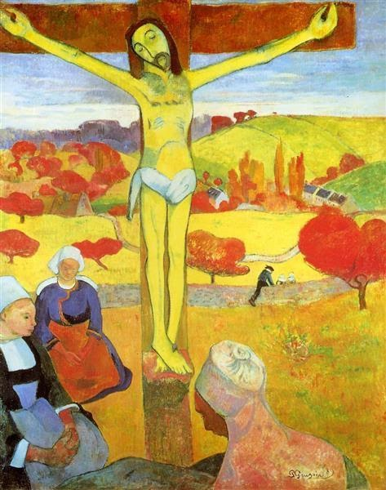

Year 4 Art Programme of Study
Project: Giacometti Sculpture and drawing
Question: Is an artists’ work ever finished? https://www.swissinfo.ch/eng/sculpture--_giacometti-s-lost-works-reappear-at-paris-show-/45665112
Curriculum aims: Be positive, Be respectful, Be resilient, Be independent, Be knowledgeable, Be ambitious, Be confident.
Curriculum drivers: Communication, Health, World Citizen, Beliefs, Aspiration
Key Knowledge (the non-negotiable facts)  Ask the project question at the start of the unit:  To know who Giacometti (1901-1966) was and respond to some of his works. (Aspiration)  - Investigated the human figure for over 40 years.  - In 2010, Giacometti’s life-sized bronze sculpture of a man, L'Homme qui marche I became one of the most expensive sculptures to ever be sold at auction  - He worked with the surrealists but then was expelled because his work was too realistic.  - Compare with the work of Augusta Savage – an African American sculptor who created human faces / bodies.  To know how to use media and techniques to represent simple figures  (Communication Health)  - Use photography to explore figures in movement from a range of angles, annotating images  - Develop understanding of simple proportions of the body.  - Apply drawing skills to support this work, focusing on further developing grades of pencil, texture and showing movement.  - Use IT to create a montage of the class’ figure drawings.  To know how artists use media for sculpture and develop confidence with some of these techniques  (Communication)  - Experiment with clay, including making joins using slip and smoothing together  - Experiment with showing textures using a range of tools and mark-making implements onto clay, including carving.  - Explore and research how armature frames can be used to give sculptures stability and strength, making notes and annotating images in a sketchbook  To know how to develop work over several sessions, managing resources  (Communication)  - Trial ideas through a maquette, developing and making changes as necessary, recording notes and annotations in a sketchbook.  - Show an awareness of how media works to allow ideas to be executed effectively over several sessions e.g. dampening and covering clay tightly in plastic for storage until next session  To know how to apply skills to create a sculpture in the style of Giacometti  (Aspiration Communication)  - End product will be a sculpture built on an armature to show a figure in movement.  - End product will be planned through drawing and making a Marquette, before making a larger-scale sculpture.  Refer back to the project question at the end of the unit: | Key concepts (artistic skills) from progression document  Developing ideas  *Make notes in a sketchbook about techniques used by artists.  *Annotate ideas for improving their work through keeping notes in a sketchbook.  *Use a sketchbook to express feelings about a subject  Drawing:  *Experiment with different grades of pencil and other implements to achieve variations in tone and make marks on a range of media.  *Include in their drawing a range of techniques and begin to understand why they best suit.  *Begin to use media and techniques (line, tone, colour) to show representation of movement in figures.  3D/Sculpture:  *Work in a safe, organised way, caring for equipment  *Secure work to continue at a later date  *Make a slip to join pieces of clay  *Decorate, coil and produce maquettes confidently when necessary  *Model over an armature  *Adapt work as and when necessary and explain why  *Gain more confidence in carving skills as a form of 3D art  *Use language appropriate to skill and technique  *Show awareness of the effect of time upon sculpture  Texture, Pattern, colour, line and tone  *Create patterns and textures with a wide range of drawing implements  *Experiment with different grades of pencil / other implements to achieve variations in tone.  Art through technology  *Use IT programs to create a piece of work that includes their own work and that of others  *Take photographs and explain their creative vision  *Take a photo from an unusual or thought-provoking viewpoint  Responding to art  *Continue to explore the work of a range of artists, craftmakers and designers, describing the differences and similarities between different practices and disciplines, and making links to their own work.  *Discuss own and others work, expressing thoughts and feelings, and using knowledge and understanding of artists and techniques  *Begin to explore a range of great artists, architects and designers in history. | Core vocabulary:  Tier 3  Marquette  Armature  slip  Tier 2  Scale  Carve  Mould  Coil  Media  Figure  annotate  texture  vision  viewpoint
Curriculum threads to be covered:-
Reading –
- Listening to and discussing a wide range of non-fiction and reference books or textbooks.
- Using dictionaries to check the meaning of words they have read.
- Draw inferences about sculptures, giving reasons using artistic evidence.

Computing –

British Values :
- To enable students to develop their self-knowledge, self-esteem and self-confidence (to develop these skills when discussing their own and others work and express thoughts and feelings using knowledge and understanding of artists and techniques).
- To encourage respect for other people (to develop respect for themselves and others when discussing others work and work done by a range of artists).
PSHE – Health and Wellbeing ˃Growing and Changing - CORAM Life Education- My Changing Body (Year 3)
Previous learning which will support the learning and skill development in this topic:
EYFS-ELG 16 Exploring and using media and materials
ELG 17 Being imaginative
Y2- Community sculpture- malleable materials and adding texture and pattern to clay.
Y3- Landscapes- developing tonal drawing and texture with different techniques and grades of pencil
NB
*Demonstrate awareness in environmental sculpture and found object art (ART day)
*Use recycled, natural and man-made materials to create sculpture (ART day
Year 5 Art Programme of Study
Project: Street Art: Banksy
Question: Is Banksy a vandal?
Curriculum aims: Be positive, Be respectful, Be resilient, Be independent, Be knowledgeable, Be ambitious, Be confident.
Curriculum drivers: Communication, Health, World Citizen, Beliefs, Aspiration
Key Knowledge (the non-negotiable facts)  To know statements:-  Ask the project question at the start of the unit:  To know where Street Art fits chronologically against other Art movements studied.  - Street Art is defined as a movement from 1990 – Present  - Street Art is often illegal and a form of vandalism.  - Street Art to be placed on a chronological timeline against the other movements studied in previous years.  To know some of the works of Banksy and compare the different styles and approaches. (World Citizen, Beliefs, Aspiration, Communication)  - Slave Labour mural, Balloon Girl, Rage the Flower Thrower, Show me the Monet, One Nation under CCTV  - Children to understand that the art work has meanings and messages.  - Compare use of colour, scale, and proportion, focussing especially on the contrast between black and white and colour in the murals and the reasons for the differences.  To know how to create initial ideas for a Banksy inspired piece of Art. (World Citizen, Aspiration, Beliefs)  - Establish a sketchbook.  - Choose a topical, current world issue for focus of Artwork e.g. climate change, social media.  - Gather initial ideas from a range of sources.  - Keep notes to consider how it will be developed further.  To know how to spray as a technique for painting. (Health)  - Understand the use of spraying as a media used for Street Art.  - Identify the risks and effects of using spray as a paint technique.  - Experiment with using spray paint (risk assess and parent permission) on large surfaces using stencils to make prints.  To know how to use colour to create different moods and atmospheres. (Communication)  - To continue developing own artwork, identifying which parts will be black and white and which will be colour and justifying these choices.  - To try different approaches and changing which areas will become colour / black and white to compare and contrast.  To know how to use composition, scale and proportion in a piece of artwork.  - Create artwork with careful thought of justification.  - Understand how scale can be used to provoke thoughts in the viewer to get messages across.  - Purposefully use proportion to highlight the message the artwork is designed to portray.  - Use sketchbook to experiment with this, showing different drafts and deliberate decision making.  To know a range of techniques for drawing and painting to be developed through the unit. (World Citizen, Beliefs, Aspiration, Communication)  - End product will be a Banksy inspired art piece using drawing and painting skills, with some aspects of spray paint.  - End product will demonstrate deliberate contrast of black and white / colour as well as thought to scale and proportion.  - End product will provoke emotion in the viewer and tackle or highlight a problem in society.  Refer back to the project question at the end of the unit: | Key concepts (artistic skills) from progression document  Responding to art  * Recognise the art of key artists and begin to place them in key movements or historical events.  * Explore a range of great artists, architects and designers in history.  * Compare different styles and approaches  Developing ideas  ∙ Keep notes which consider how a piece of work may be developed further  ∙ Use sketchbooks to collect and record visual information from different sources as well as planning, trying out ideas, plan colours and collect source material for future works.  ∙ Adapt work as and when necessary and explain why.  Drawing  ∙ Work in a sustained and independent way to develop their own style of drawing.  ∙ This style may be through the development of: line, tone, pattern, texture.  ∙ Develop an awareness of composition, scale and proportion in their paintings.  Painting  *Work in a sustained and independent way to develop their own style of painting. This style may be through the development of: colour, tone and shade.  ∙ Purposely control the types of marks made and experiment with different effects and textures inc. blocking in colour, washes, thickened paint creating textural effects.  ∙ Mix colour, shades and tones with confidence building on previous knowledge.  ∙ Understanding which works well in their work and why.  Texture, Pattern, colour, line and tone  * Consider the use of colour for mood and atmosphere  Printmaking  ∙ Describe techniques and processes.  ∙ Adapt their work according to their views and describe how they might develop it further.  ∙ Develop their own style using tonal contrast and mixed media.  ∙ Start to overlay prints with other media.  *Use tools in a safe way. Continue to gain experience in overlaying colours  *Demonstrate experience in a range of printmaking techniques | Core vocabulary:  Tier 3  Vandalism  Tier 2  Composition  Scale  Proportion  Contrast  Media  Scale  Provoke  Proportion
Curriculum threads to be covered:-
Reading –
- Continuing to read and discuss and increasingly wide range of non-fiction and reference books or text books.
- Ask questions to improve understanding.
- Drawing inferences - (look at Banksy’s motivation to produce some of his art work, and the messages)
- Distingush between statements of fact and opinion.
- Participate in discussions about books that are read to them and those they can read for themselves , building on their own and others’ ideas and challenging views courteously.
- Provide reasoned justifications for their views.

Computing –

British Values :
- To enable students to develop their self-knowledge, self-esteem and self-confidence.
- To enable students to distinguish right from wrong and to respect the civil and criminal law of England (to develop understanding of the Street Art movement and place it in context of current exploration of Street Art; to raise awareness of ‘legal’ forms of Street Art and identify right from wrong when exploring this form of Art).
- To encourage students to accept responsibility for their behaviour, show initiative, and to understand how they can contribute positively to the lives of those living and working in the locality of the school and to society more widely (to explore how and why the Street Art movement developed; to raise awareness of crucial social issues/themes tackled through this Art and key artists who contributed to this movement; to link this to pupils own potential to show initiative and contribute positively to the school/locality).
- To encourage respect for other people
PSHE – Living in the Wider World ˃Rules, Rights and Responsibilities - CORAM Life Education- Local Councils (Year 5)
Previous learning which will support the learning and skill development in this topic:
EYFS-ELG 16 Exploring and using media and materials
ELG 17 Being imaginative

Y3- Pop Art- linked to popular culture with some political statements, print making and mixing media
Y4- Post-impressionism- Developed use of the sketchbook to develop and modify ideas

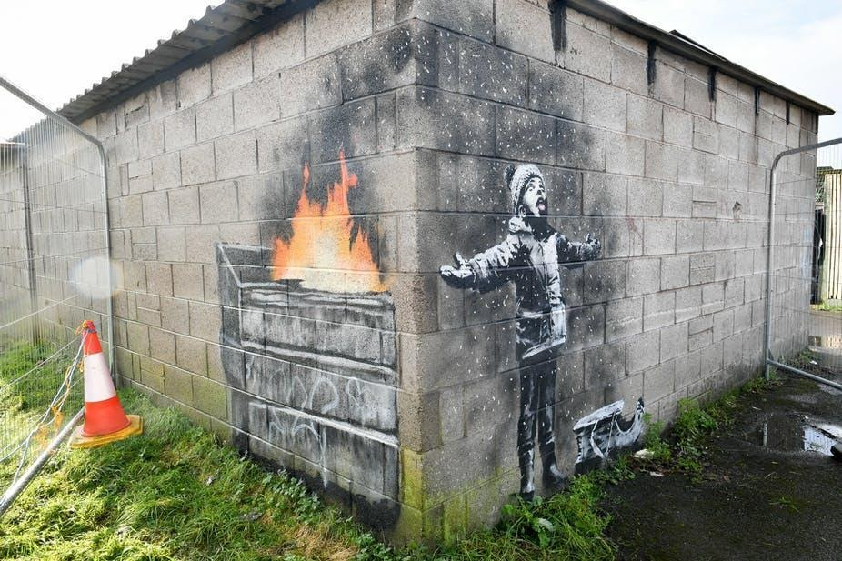

Year 5 Art Programme of Study
Project: Abstract Expressionism: Jackson Pollock, Helen Frankenthaler, Arshile Gorky, Janet Sobe 1940s-1950s
Question: Should art have meaning?
Curriculum aims: Be positive, Be respectful, Be resilient, Be independent, Be knowledgeable, Be ambitious, Be confident.
Curriculum drivers: Communication, Health, World Citizen, Beliefs, Aspiration
Key Knowledge (the non-negotiable facts)  To know statements:-  Ask the project question at the start of the unit:  To know where Abstract expressionism fits chronologically against other Art movements studied.  - Surrealism 1917-1950 (Y6)  - 1941 “the weeping Woman” Picasso  - Pop art- 1950s-1960s  - Cover key artists listed above.  To know some of the works of Jackson Pollock and compare the different styles and approaches. (Aspiration, Communication)  - The She-wolf and The Mask are examples of his later work with links to cubism and Picasso where he painted on an easel with a brush. This work was less popular at the time.  - Galaxy (1947), Number 17A, Number 5 (1948- his most famous and expensive artwork) are examples of his “drip period” (1947-1950). (Could compare to contemporary pouring art prevalent on YouTube)  - Children to understand that Pollock created art using movement, for the viewer to appreciate the line and form rather than an object.  - Compare use of colour, and technique.  To know how to use the drip technique as a technique for painting.  - Control the marks made  - Explore and adapt media- different types of paint, thickened paint etc to create textural effects  - Mix paints for colour, tone and texture  - Use whole body movements to express creativity  To know how to use colour to create different moods and atmospheres. (Communication)  - Decide upon a tonal palettes of complimentary or contrasting shades and compare effectiveness.  - Use this to support final piece, explaining choices  To know how scale affects the impact of a piece of artwork. (Communication)  - Create artwork with careful thought of justification.  - Understand how scale changes the effect of a piece, comparing the impact of small scale and larger scale pieces (Pollock did large scale artwork)  - Work on a large scale.  To express thoughts and feelings, developing appreciation for art, even when it is unconventional (Communication, Beliefs)  - Compare Pollocks approach and intent to that of other artists  - Discuss and review own and others’ work constructively.  To know a range of techniques for painting to be developed through the unit. (Beliefs, Aspiration, Communication)  - End product will be a Pollock inspired art piece using drip technique  - End product will demonstrate deliberate use of either tonal or contrasting colours and textures of paint, with a base wash.  - End product will celebrate line, colour and texture- art in its purest form.  Refer back to the project question at the end of the unit: | Key concepts (artistic skills) from progression document  Responding to art  * Recognise the art of key artists and begin to place them in key movements or historical events.  * Explore a range of great artists, architects and designers in history.  * Compare different styles and approaches  *Discuss and review own and others’ work, expressing thoughts and feelings, and identify modifications and how they can be developed further.  Developing ideas  ∙ Keep notes which consider how a piece of work may be developed further  ∙ Use sketchbooks to collect and record visual information from different sources as well as planning, trying out ideas, plan colours and collect source material for future works.  ∙ Adapt work as and when necessary and explain why.  Painting  *Work in a sustained and independent way to develop their own style of painting. This style may be through the development of: colour, tone and shade.  ∙ Purposely control the types of marks made and experiment with different effects and textures inc. blocking in colour, washes, thickened paint creating textural effects.  ∙ Mix colour, shades and tones with confidence building on previous knowledge.  ∙ Understanding which works well in their work and why.  Texture, Pattern, colour, line and tone  * Consider the use of colour for mood and atmosphere  *Tones and tints became increasingly subtle as understanding and skill in using the techniques develops | Core vocabulary:  Tier 3  Drip technique,  Pure abstraction,  Expression without form  Tier 2  Scale  Proportion  Contrast  Media  Scale  Line  Thickened  Pour  Tonal  Contrasting  Appreciation
Curriculum threads to be covered:-
Reading –
- Drawing inferences (look at artists mood when creating some abstract work)
- Discussing their understanding and exploring the meaning of words in context.
- Provide reasoned justifications for their views.

Computing –

British Values :
- To enable students to develop their self-knowledge, self-esteem and self-confidence (to develop these skills when discussing and reviewing own and others work; to develop self-confidence when making justifiable adaptations to their own work and being able to explain why).
- To encourage respect for other people (to develop respect for work, styles and approaches by key artists; to develop respect for others when discussing and reviewing their own and others work, being able to identify modifications and explain how these can be developed further).
PSHE – Relationships ˃Valuing Difference - CORAM Life Education- Kind Conversations (Year 5)
Health and Wellbeing ˃Keeping Safe - CORAM Life Education- Being Assertive (Year 5)
Health and Wellbeing ˃Keeping Safe - CORAM Life Education- Communication (Year 5)
Previous learning which will support the learning and skill development in this topic:
EYFS-ELG 16 Exploring and using media and materials
ELG 17 Being imaginative
Y1- Kandinsky Abstract art
Y2- Art day Picasso “The Weeping Woman” and paintings such as “The mask” 1941 in similar style.
Y3- Pop art/Landscapes- effects of complimentary and contrasting colours

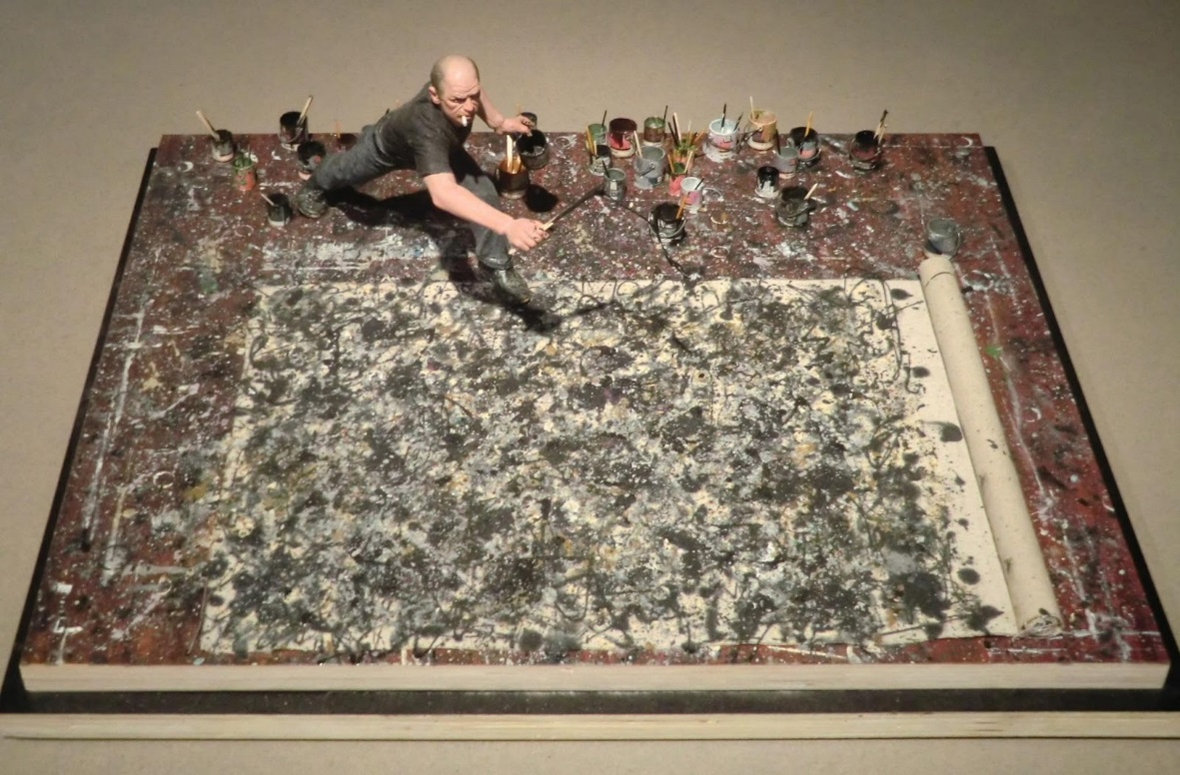

Year 6 Art Programme of Study
Project: Surrealism 1917-1950- Drawing and painting
Question: Should Art be shocking?
Curriculum aims: Be positive, Be respectful, Be resilient, Be independent, Be knowledgeable, Be ambitious, Be confident.
Curriculum drivers: Communication, Health, World Citizen, Beliefs, Aspiration
Key Knowledge (the non-negotiable facts)  Ask the project question at the start of the unit:  To know where surrealism fits chronologically against other Art movements  - Expressionism Y4 1905-20s  - Abstract expressionism Y5 1940s-50s  - Pop art Y3 1950s-1960s,  - Surrealism 1920s - 1950s  To know some works of the Surrealism movement (Aspiration)  - Compare styles and approaches of surrealist movement, recognising key pieces, what they mean and how they make us feel.  - Christ of Saint John on the Cross- Explore Dali’s use of perspective how a single point has been used to create this effect  - The Son of Man- Magritte, Persistence of memory- Dali, Tortured- Breton  - Cover information about key artists – Dali, Kahlo, Breton  To know how to respond to art constructively (Communication, Beliefs)  - Discuss and review own and others’ work constructively.  - Express own feelings and responses, being respectful of differing perspectives  - Understand that art is subjective and is interpreted in different ways  To know how to work in a sustained way, building work in stages.  - Rough out composition, add more definite forms and outlines, then add in detail and textures to draw over several sessions  - Use drawings as a starting point to paintings, building colour and texture over several sessions in stages  To know artists express ideas and feelings in a surreal way to shock or surprise us (Communication)  - End product will be a shocking or surprising surreal image  - End product will be painting developed over several sessions  - End product will express a feeling or idea, which can be explained by the artist  Refer back to the project question at the end of the unit: | Key concepts (artistic skills) from progression document  Developing ideas  ∙ Keep notes which consider how a piece of work may be developed further  ∙ Use sketchbooks to collect and record visual information from different sources as well as planning, trying out ideas, plan colours and collect source material for future works.  ∙ Adapt work as and when necessary and explain why.  Drawing  *Work in a sustained and independent way to develop their own style of drawing  *This style may be through the development of line, tone, pattern, texture  *Draw for a sustained period of time over a number of sessions working on one piece  *Have opportunities to develop further simple perspective in their own work using a single focal point and horizon  *Develop an awareness of composition, scale and proportion in their paintings  Painting  *Work in a sustained and independent way to develop their own style of painting. This style may be through the development of colour, tone and shade  *Mix colour, shades and tones with confidence, building on previous knowledge.  *Understanding which works well in their work and why  Texture, Pattern, colour, line and tone  * Consider the use of colour for mood and atmosphere  *Tones and tints and light and shade became increasingly subtle as understanding and skill in using the techniques develops  Responding to art  * Recognise the art of key artists and begin to place them in key movements or historical events.  * Explore a range of great artists, architects and designers in history.  * Compare different styles and approaches  *Discuss and review own and others’ work, expressing thoughts and feelings, and identify modifications and how they can be developed further. Identify artists who have worked in a similar way to their own work. | Core vocabulary:
Curriculum threads to be covered:-
Reading –
- Continuing to read and discuss an increasingly wide range of non-fiction and reference or text books.
- Asking questions to improve their understanding.
- Drawing inferences
- Participate in discussions about books that are read to them and those they can read for themselves , building on their own and others’ ideas and challenging views courteously.
- Provide reasoned justifications for their views.

Computing –

British Values :
- To enable students to develop their self-knowledge, self-esteem and self-confidence (to develop these skills when discussing and reviewing own and others work and expressing thoughts and feelings understanding the work of key artists and their techniques; to be able to develop self-confidence when making justifiable adaptations to their work and being able to explain why).
- To encourage students to accept responsibility for their behaviour, show initiative, and to understand how they can contribute positively to the lives of those living and working in the locality of the school and to society more widely (to develop a good understanding of the contributions of key artists to the Surrealism movement; to understand how their initiative left a huge impact on society more widely; to link this with pupils own potential to show initiative and how this can have a positive contribution to the school/locality).
- To encourage respect for other people (to develop respect when comparing different styles and approaches; to develop respect when discussing and reviewing own work and others when identifying modifications and expressing how these could be developed further).
PSHE – Relationships ˃Feelings and Emotions - CORAM Life Education- Assertiveness Skills (Year 6)
Relationships ˃ Valuing Difference - CORAM Life Education- Respecting Differences(Year 6)
Relationships ˃Valuing Difference - CORAM Life Education- OK to be different (Year 6)
Living in the Wider World ˃Rules Rights and Responsibilities - CORAM Life Education- Tolerance and Respect for Others (Year 6)
Previous learning which will support the learning and skill development in this topic:
EYFS-ELG 16 Exploring and using media and materials
ELG 17 Being imaginative
Y3- Pop art- introduction to perspective
Y4- Post-impressionism- developing more sustained work
Y5- Banksy- expressing ideas and feelings through provocative artwork

NB Addressed in Y6 During DT unit “Upcycling”- *Use print as a starting point to embroidery
Year 6 Art Programme of Study
Project: Goldsworthy natural sculpture and digital art
Question: Can nature become “art”?
Curriculum aims: Be positive, Be respectful, Be resilient, Be independent, Be knowledgeable, Be ambitious, Be confident.
Curriculum drivers: Communication, Health, World Citizen, Beliefs, Aspiration
Key Knowledge (the non-negotiable facts)  Ask the project question at the start of the unit:  To know how artists take inspiration from nature (Communication, World Citizen)  - Explore sculptural forms in the environment.  - Explore textures, light, shade, composition of natural objects using photography to capture for future use.  - Apply drawing techniques from LKS2 with a focus on different purposes.  - Use sketchbook to record, annotate and develop ideas and thoughts.  - Learn some key knowledge and facts about Goldsworthy.  To know how to use software to alter, adapt and create work  - Use simple art software to upload and adapt digital images taken  - Use software to create a montage of images, considering colour, size, rotation  To know techniques artists use to carve a form and use clay and armatures  - Further develop carving techniques from soft, natural materials.  - Carve a simple form which will become part of end product sculpture.  - Further develop work from Y4 using an armature to give structure to sculpture  - Further develop effective use of clay techniques to give greater depth to work  To know how to apply techniques effectively (Communication)  - Taking inspiration from Goldsworthy, develop ideas for sculpture using sketchbook to show development and links to the artist.  - Plan how to join parts of the sculpture.  - Respond to problems as they occur, using experience of techniques  To know how artists combine techniques to create 3D sculptures  (Aspiration)  - End product will be a sculpture inspired by nature, including a carved element, an element of clay and use of found, natural materials or structures.  - End product will be reviewed effectively through use of sketchbook, including links to other artists’ work  Refer back to the project question at the end of the unit: | Key concepts (artistic skills) from progression document  Developing ideas  *Use sketchbooks to plan a sculpture through drawing and other preparatory work  *Use the sketchbook to plan how to join parts of the sculpture.  ∙ Keep notes which consider how a piece of work may be developed further  ∙ Use sketchbooks to collect and record visual information from different sources as well as planning, trying out ideas, plan colours and collect source material for future works.  ∙ Adapt work as and when necessary and explain why.  Drawing  *Use different techniques for different purposes i.e. shading, hatching within their own work, understanding which works well in their own work and why.  *Develop their own style using tonal contrast and mixed media  3D/Sculpture  *Work in a safe, organised way, caring for equipment. Secure work to continue at a later date.  *Model and develop work through a combination of pinch, slab and coil  *Work around armatures or over constructed foundations  *Demonstrate experience in the understanding of different ways of finishing work: glaze, paint, polish  *Demonstrate experience in relief and freestanding work using a range of media  *Recognise sculptural forms in the environment: furniture, buildings  *Confidently carve a simple form  *Solve problems as they occur  *Use language appropriate to skill and technique  Art through technology  *Scan an image or take digital photographs and use software to alter them, adapt them and create work with meaning  *Compose a photo with thought for textural qualities, light and shade  *Have opportunities to explore modern and traditional artists using ICT and other resources  *Combine a selection of images using digital technology considering colour, size and rotation  Responding to art  *Compare different styles and approaches  *Discuss and review own and others’ work, expressing thoughts and feelings, and identify modifications and how they can be developed further. Identify artists who have worked in a similar way to their own work. | Core vocabulary:  Tier 3  Tonal contrast  Sculptural forms  armature  Tier 2  Shading, hatching,  Textural qualities  Light  shade  Relief  Freestanding  composition  Pinch  Slab  Coil  Glaze  Paint  Polish  Carve
Curriculum threads to be covered:-
Reading –
- Reading books that are structured in different ways and reading for a range of purposes.
- Discussing their understanding and exploring the meaning of words in context.

Computing –

British Values:
- To enable students to develop their self-knowledge, self-esteem and self-confidence (to develop these skills when discussing and reviewing own and others work and expressing thoughts and feelings understanding the work of key artists and their techniques; to be able to develop self-confidence when making justifiable adaptations to their work and being able to explain why).
- To encourage respect for other people (to develop respect when comparing different styles and approaches; to develop respect when discussing and reviewing own work and others when identifying modifications and expressing how these could be developed further).
PSHE – Living in the Wider World ˃Caring for the environment - CORAM Life Education- Community Art (Year 6)
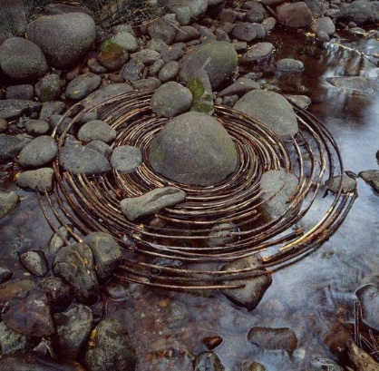
Previous learning which will support the learning and skill development in this topic:

EYFS-ELG 14 The world
ELG 15 Technology
ELG 16 Exploring and using media and materials
ELG 17 Being imaginative
Y1- Goldsworthy introduction
Y4- Giacometti- using armatures and developing techniques for 3D artwork, making slip and storing clay to continue at a later date

