Our Lady of Lincoln Catholic Primary School

Chemistry Curriculum

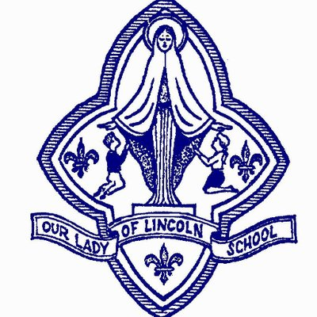

Chemistry Whole School Long Term Overview
Year 1 | Everyday Materials  Is plastic a good material?
Year 2 | Everyday Materials  Are all materials the same?
Year 3 |  | Rocks and Soils  Are fossils useful?
Year 4
Year 5 | Everyday Materials  When something dissolves, does it disappear?
Year 6

Everyday Materials
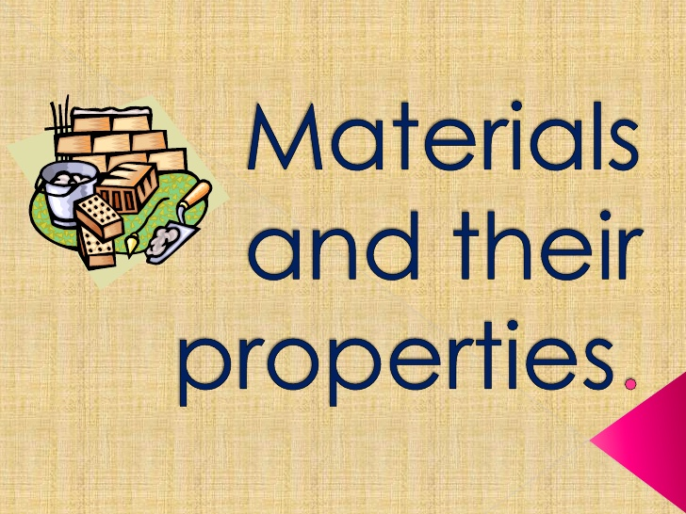

Year 1 Science Programme of Study - Chemistry
Project: Everyday Materials
Question: Is plastic a good material?
Curriculum aims: Be positive, Be respectful, Be resilient, Be independent, Be knowledgeable, Be ambitious, Be confident.
Curriculum drivers: Communication, Health, World Citizen, Beliefs, Aspiration
Key Knowledge (the non-negotiable facts)  To know statements:-  Ask the project question at the start of the unit:  NB: Children should take part in practical activities throughout.  To know the difference between an object and the material that it is made from  - Each material can be used to make a range of different things; for example, wood can be used to make tables, chairs, spoons, pencils, shoes, doors, floors and many more things.  - An object can be made out of different materials used together; for example, a chair can be made from metal and wood and plastic.  - Children struggle with the differentiation between the object and the material.  To know and name everyday materials  - Identify wood, plastic , glass, metal, water and rock  - Material hunt  To know the simple physical properties of a variety of everyday materials  - Hard/ soft, shiny/dull, rough / smooth, bendy/ not bendy/ flexible, waterproof/ not waterproof, not absorbent/ absorbent, opaque/ transparent, stretchy/ stiff.  - Explore other materials not listed too: fabrics, elastic, foil, paper  To know how to compare and group a variety of everyday materials due to simple physical properties  - Use the scientific terms above as much as possible  To know the work of a famous scientist (Aspiration)  - Alexander Parkes (29 December 1813 – 29 June 1890) was a metallurgist and inventor from Birmingham, England. He created Parkensine, the first man-made plastic.  To know some of the uses of plastic but some of the problems it presents with waste (World Citizen)  - Explore some of the useful functions of plastic.  - Start to discuss some of the problems with disposing of plastic and the environmental damage it can cause.  Refer back to the project question at the end of the unit: | Working Scientifically skills from progression document  * Experience different types of science enquiries, including practical activities.  * Begin to recognise ways in which they might answer scientific questions.  * Carry out simple tests  * Use simple features to compare objects, materials and living things, and with help, decide how to sort and group them.  *Observe closely using simple equipment with help, observe changes over time.  * With guidance, they should begin to notice patterns and relationships.  * Use their observations and ideas to suggest answers to questions.  * Talk about what they have found out and how they have found it out. | Core vocabulary:  Tier 3  Flexible  Opaque  Transparent  Absorbent  Tier 2  Shiny  Dull  Stretchy  bendy  Materials  Object  Compare  Sort  Properties  Explore
Curriculum threads to be covered:-

Reading –
- Listening to and discussing non-fiction at a level beyond that at which they can read independently.
- Being encouraged to link what they read or hear read to their own experiences.
- Discussing word meanings, linking new meanings to those already known.
- Drawing on what they already know or on background information and vocabulary provided by the teacher.
- Explain clearly their understanding of what is read to them.
Computing –

British Values – To encourage students to accept responsibility for their behaviour, show initiative, and to understand how they can contribute positively to the lives of those living and working in the locality of the school and to society more widely – identify materials that are not biodegradable and therefore raise awareness to make responsible choices with different materials to contribute positively to the society

PSHE – Living in the Wider World ˃Rules, Rights and Responsibilities- CORAM Life Education- Taking Care of Something (Year 1)

Previous learning which will support the learning and skill development in this topic:

EYFS-ELG 14 The world

Year 2 Science Programme of Study - Chemistry
Project: Everyday Materials
Question: Are all materials the same?
Curriculum aims: Be positive, Be respectful, Be resilient, Be independent, Be knowledgeable, Be ambitious, Be confident.
Curriculum drivers: Communication, Health, World Citizen, Beliefs, Aspiration
Key Knowledge (the non-negotiable facts)  To know statements:-  Ask the project question at the start of the unit:  NB: Children should take part in practical activities throughout.  To know how to identify and compare the suitability of a variety of everyday materials for particular uses  - To look at plastic, wood, metal , glass, brick , rock, paper and cardboard  To know how shapes of solid objects are made from some materials being changed  - To look at squashing, bending, twisting and stretching of shapes.  To know why some materials are more suitable that others for certain objects  - Some materials are more suitable than others to be objects  - Consider expense, shape, flexibility , wear and tear, strength, comfort  To know about how materials are recycled (World Citizen)  - Look at a recycling centre and the process of recycling  - How we need to look after the world as a world citizen  - Why is it important to recycle?  - How can we recycle?  Refer back to the project question at the end of the unit: | Working Scientifically skills from progression document  * Carry out simple tests  * Use simple features to compare objects, materials and living things, and with help, decide how to sort and group them.  *Observe closely using simple equipment with help, observe changes over time.  * Use simple measurements and equipment (e.g. hand lenses, egg timers) to gather data.  * Use their observations and ideas to suggest answers to questions.  * Talk about what they have found out and how they have found it out. | Core vocabulary:  Tier 3  Flexibility  Durability  Tier 2  Rubber  Plastic  Wood  Materials  Variety  Compare  Recycling  Waste  Environment
Curriculum threads to be covered:-

Reading –
• Listening to, discussing and expressing views about a wide range of non-fiction at a level beyond that at which they can read independently.
• Discussing and clarifying the meanings of words, linking new meanings to known vocabulary.
• Drawing on what they already know or on background information and vocabulary provided by the teacher.
• Answering and asking questions.

Computing –

British Values – To encourage students to accept responsibility for their behaviour, show initiative, and to understand how they can contribute positively to the lives of those living and working in the locality of the school and to society more widely

PSHE – Living in the Wider World ˃Caring for the Environment- CORAM Life Education- How can we look after our environment? (Year 2)

Previous learning which will support the learning and skill development in this topic:
Everyday material year 1:
To know the difference between an object and the material that it is made from
To know and name everyday materials
To know the simple physical properties of a variety of everyday materials
To know how to compare and group a variety of everyday materials due to simple physical properties

EYFS-ELG 14 The world
ELG 16 Exploring and using media and materials

Year 5 Science Programme of Study - Chemistry
Project: Properties and changes of materials
Question: When something dissolves, does it disappear?
Curriculum aims: Be positive, Be respectful, Be resilient, Be independent, Be knowledgeable, Be ambitious, Be confident.
Curriculum drivers: Communication, Health, World Citizen, Beliefs, Aspiration
Key Knowledge (the non-negotiable facts)  To know statements:-  Ask the project question at the start of the unit:  To know how to compare and group together everyday materials on the basis of their properties  - Materials can be grouped according to hardness, solubility, transparency, conductivity and response to magnets  To know that some materials will dissolve in liquid to form a solution and describe how to recover a substance from a solution  - Some substances dissolve when you mix them with water. ... Substances that dissolve in water are called soluble substances. When you mix sugar with water, the sugar dissolves to make a transparent solution. Salt is soluble in water too.  - Know how to use evaporation to separate a solution.  To know how to separate gases, liquids and solids using knowledge of them  - Substances can be separated using filtering, sieving and evaporating.  ( thia a (a great opportunity for prediction)  - Pure gases can be separated from air by first cooling it until it liquefies, then selectively distilling the components at their various boiling temperatures. The process can produce high purity gases but is energy-intensive.  - DISTILLATION. In distillation, a mixture of liquids is heated in a flask. The liquid with the lower boiling point evaporates (changes to a vapour) first, and is condensed (changes back to a liquid) and collected. The liquid with the higher boiling point and any solid particles are left behind in the flask.  - Mixtures can be separated using a variety of techniques.. Distillation takes advantage of differences in boiling points. Evaporation removes a liquid from a solution to leave a solid material. Filtration separates solids of different sizes.  To know about particular uses of everyday materials  - Think about the world we live in and which materials are used for which objects  - Could materials have multiple uses and why, which is best?  To know about reversible changes  - Reversible and irreversible reactions are different. A reversible change is a change that can be undone or reversed. If you can get back the substances you started the reaction with, that's a reversible reaction. ... Examples of reversible reactions include dissolving, evaporation, melting and freezing.  To know new materials can be formed and this kind of change is not usually reversible  - What Is An Irreversible Change? An irreversible change is when something cannot be changed back to its original form. In many irreversible changes, new materials and substances are formed.  Refer back to the project question at the end of the unit: | Working Scientifically skills from progression document  * Use their Science experiences to explore ideas and raise different kinds of questions.  * Talk about how Scientific ideas have developed over time.  * Recognise when and how to set up comparative and fair tests and explain which variables need to be controlled and why.  * Make their own decisions about what observations to make, what measurements to use and how long to make them for.  * Choose the most appropriate equipment to make measurements with increasing precision and explain how to use it accurately. Take repeat measurements where appropriate.  *Use their results to make predictions and identify when further observations, comparative and fair tests might be needed. | Core vocabulary:  Tier 3  solubility, transparency, conductivity  dissolve  soluble  substance  filtering  separation  purity  evaporate  filtration  solvent  distillation  condensed  reversible  irreversible  Tier 2  Solid  Liquid  Gases  Energy  mixture  change
Curriculum threads to be covered:-
Reading -
- participate in discussions about books that are read to them and those they can read for themselves, building on their own and others’ ideas and challenging views courteously
- continuing to read and discuss an increasingly wide range of non-fiction and reference books or textbook

Computing –

British Values –
- To encourage students to accept responsibility for their behaviour, show initiative, and to understand how they can contribute positively to the lives of those living and working in the locality of the school and to society more widely (linking responsible choices to reversible and irreversible changes).
PSHE
- Living in the Wider Community ˃ Caring for the Environment- CORAM Life Education- Rights, Responsibilities and Duties/ My School Community/ Mo Makes a Difference (Year 5)
Previous learning which will support the learning and skill development in this topic:
Every day materials: Year 2:
To know how to identify and compare the suitability of a variety of everyday materials for particular uses
To know how shapes of solid objects are made from some materials being changed
To know why some materials are more suitable that others for certain objects

States of Matter: Year 4:
To know how to compare and group materials together based on if they are solids, liquids or gases.
To know that some materials change state when they are heated or cooled.

EYFS-ELG 12 Shape, space and measures
ELG 14 The world

Rocks and Soils
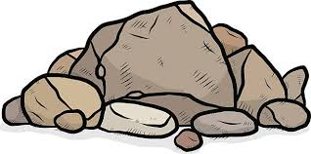

Year 3 Science Programme of Study - Chemistry
Project: Rocks and Soils
Question: Are fossils useful?
Curriculum aims: Be positive, Be respectful, Be resilient, Be independent, Be knowledgeable, Be ambitious, Be confident.
Curriculum drivers: Communication, Health, World Citizen, Beliefs, Aspiration
Key Knowledge (the non-negotiable facts)  To know statements:-  Ask the project question at the start of the unit:  To know that there are different kinds of rocks and they can be grouped according to appearance and physical properties.  - Three main groups: igneous, metamorphic, sedimentary rocks  - Rocks form the Earth’s outer layer, the crust  - Igneous rocks are formed when magma cools in the Earth’s crust or lava cools on the ground or seabed  To know how to describe fossils in simple terms and how they are formed when things have lived have been trapped within rock.  - Fossils are formed in a number of ways but most are formed when a plant or animal dies in a watery environment and is buried in mud and silt.  - Soft tissues quickly decompose leaving the hard bones or shells behind  - Over time sediment builds over the top and hardens onto rock.  To know that soils are made from rocks and organic matter.  - Soil minerals form the basis of soil  - They are produced from rocks through the process of weathering and natural erosion  - Water, wind, temperature change, gravity, chemical interaction, living organisms and pressure differences help break down the materials  To know some different types of soil and their properties  - Sandy soils, clay soil, chalky soil, peat. – how plants grow in each of these.  - Touch on the work of George Washington Carver – a black man born into slavery but who developed techniques to improve soil by restoring nitrogen to their soils through crop rotation.  To know the work of a leading Scientist Mary Anning (Aspiration)  - Mary Anning was a famous English fossil hunter.  - She found a full Ichthyosaurus a marine reptile  - A plesiosaur in 1823 ( one was found hear st faiths infants that’s why they have a dinosaur symbol, it’s in the collection museum)  - She was not taken seriously for a long time because she was a woman from a fairly poor background too.  Refer back to the project question at the end of the unit: | Working Scientifically skills from progression document  * Raise their own relevant questions about the world around them.  * Should be given a range of scientific experiences including different types of Science enquiries to answer questions.  * Start to make their own decisions about the most appropriate type of Scientific enquiry they might use to answer questions.  * Make systematic and careful observations  * Begin to look for naturally occurring patterns and relationships and decide what data to collect to identify them.  * With help, pupils should look for changes, patterns, similarities and differences in their data in order to draw simple conclusions and answer questions.  *Use relevant simple scientific language to discuss their ideas and communicate their findings in ways that are appropriate for difference audiences, including oral and written explanations, displays or presentations of results and conclusions. | Core vocabulary:  Tier 3  igneous, metamorphic, sedimentary  Tier 2  Rocks  Fossils  Physical properties  Appearance
Curriculum threads to be covered:-

Reading –
- Listening to and discussing a wide range of non-fiction and reference books or textbooks.
- Asking questions to improve their understanding of a text.
- Retrieve and record information from non-fiction.
- Participate in discussion about both books that are read to them and those they can read for themselves, taking turns and listening to what others say.
Computing –

British Values –
- To encourage students to accept responsibility for their behaviour, show initiative, and to understand how they can contribute positively to the lives of those living and working in the locality of the school and to society more widely. (Grow in awareness that knowledge from the past (fossils) empowers us to make positive choices for the future; grow in knowledge and understanding of how natural elements can cause erosion therefore have an impact on human environments).
PSHE – N/A

Previous learning which will support the learning and skill development in this topic:
Everyday materials: Year 2:
To know how to identify and compare the suitability of a variety of everyday materials for particular uses.

EYFS-ELG 14 The world

